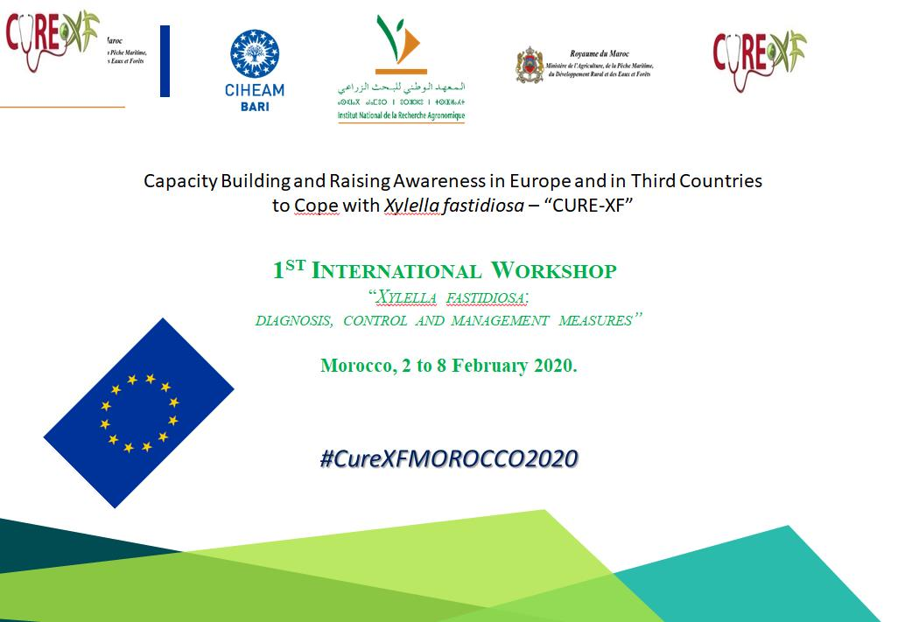
1st International Workshop on: “Xylella fastidiosa – diagnosis, control, and management measures” in Morocco from 2 to 8 February 2020.
FTN dissemination Report
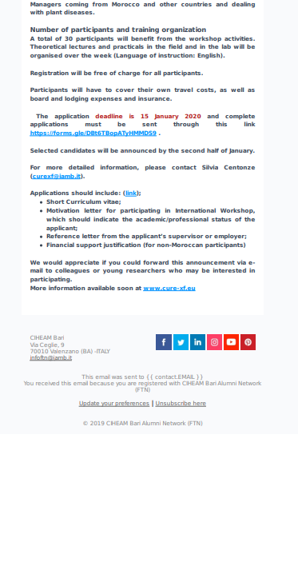
Starting campaign-date 2nd January 2020
2,027 Openers / 48 hrs of the launching
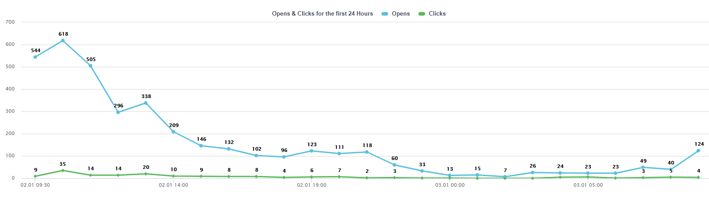

Geographical distribution of 2,027 Openers/FTN Contacts
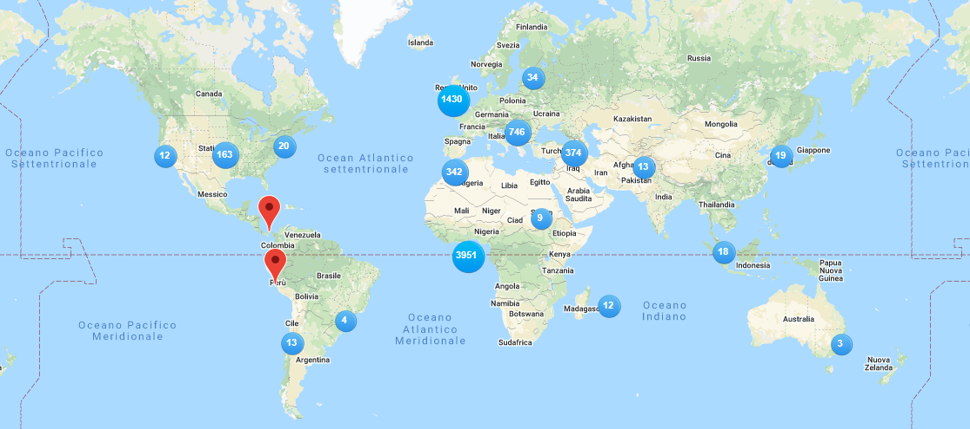

COUNTRY | OPENS/Clicked
United States | 192 2.68%
Italy | 188 2.62%
Morocco | 181 2.53%
Turkey | 153 2.14%
France | 148 2.07%
Germany | 95 1.33%
Tunisia | 95 1.33%
Egypt | 94 1.31%
United Kingdom | 62 0.87%
Serbia | 61 0.85%
Algeria | 60 0.84%
Lebanon | 58 0.81%
Iran | 53 0.74%
Jordan | 52 0.73%
Netherlands | 42 0.59%
Russia | 34 0.47%
Austria | 27 0.38%
Switzerland | 22 0.31%
Spain | 21 0.29%
Bosnia and Herzegovina | 19 0.27%
Iraq | 19 0.27%
Singapore | 15 0.21%
United Arab Emirates | 15 0.21%
Saudi Arabia | 14 0.20%
Slovakia | 13 0.18%
Mauritius | 12 0.17%
Pakistan | 12 0.17%
Macedonia | 12 0.17%
Chile | 12 0.17%
Greece | 11 0.15%
Japan | 10 0.14%
Albania | 10 0.14%
Ukraine | 10 0.14%
Syria | 9 0.13%
Croatia | 9 0.13%
Estonia | 8 0.11%
Israel | 8 0.11%
Bulgaria | 8 0.11%
Poland | 6 0.08%
Latvia | 6 0.08%
Azerbaijan | 5 0.07%
Czech Republic | 4 0.06%
Hungary | 4 0.06%
Nigeria | 4 0.06%
Brazil | 4 0.06%
Finland | 4 0.06%
Australia | 3 0.04%
China, Republic of (Taiwan) | 3 0.04%
Moldova | 3 0.04%
Georgia | 3 0.04%
Canada | 3 0.04%
Vietnam | 3 0.04%
Libya | 2 0.03%
Romania | 2 0.03%
Hong Kong | 2 0.03%
China, People's Republic of | 2 0.03%
Lithuania | 2 0.03%
Ethiopia | 2 0.03%
Belgium | 2 0.03%
Qatar | 2 0.03%
Korea, South | 2 0.03%
Kuwait | 2 0.03%
Sudan | 2 0.03%
Malta | 1 0.01%
Denmark | 1 0.01%
Mauritania | 1 0.01%
Argentina | 1 0.01%
India | 1 0.01%
Peru | 1 0.01%
Panama | 1 0.01%
Luxembourg | 1 0.01%
Others/ EU | 1,229 17.15%

